Microprocessor – high level language, hardware support for os general purpose ALU and mem/io interface

Microcontrollers limited instruction assembler and low level programing optimized for power

Real time system - a system or device that is required to respond to external events within a specificied time period

ARM is advanced RISC Machine

Risc- reduced instruction set computer, more complex compiler

Cisc – complex instruction set computing, more complex processor

ARM -32

Thumb -16

Data alignment

Endianness , little( high mem-msb/low mem-lsb) big(high mem-lsb/low mem msb

Von Neuman – only uses one memory bus for instructions fetching and data access

-simple hardware and glue logic design code and data located at same address

Harvard – requires 2 bus controllers between processor and memory

-data and code are separate

Inproved performance better instruction pipeline

Less code corruptions

Top vs bot boot – refers to reset vector

* Lowest value of memory address is considered the top
* Highest value of memory address is considered the bottom

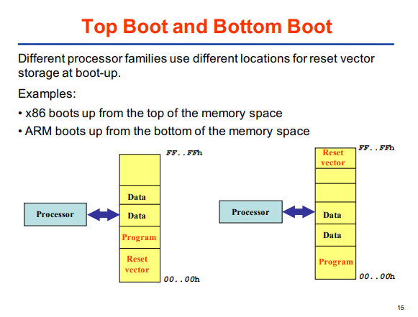

Two states

Arm state and thumb state switched using BX branch and exchange instruction

Modes

* Non privileged modes – user
* Privileged mode
  + System same as user but allows access to fiq and irq
  + Supervisor no restricutions
  + Fiq
  + Irq
  + Abort
  + Undefine

Fetch decode execute

CPSR

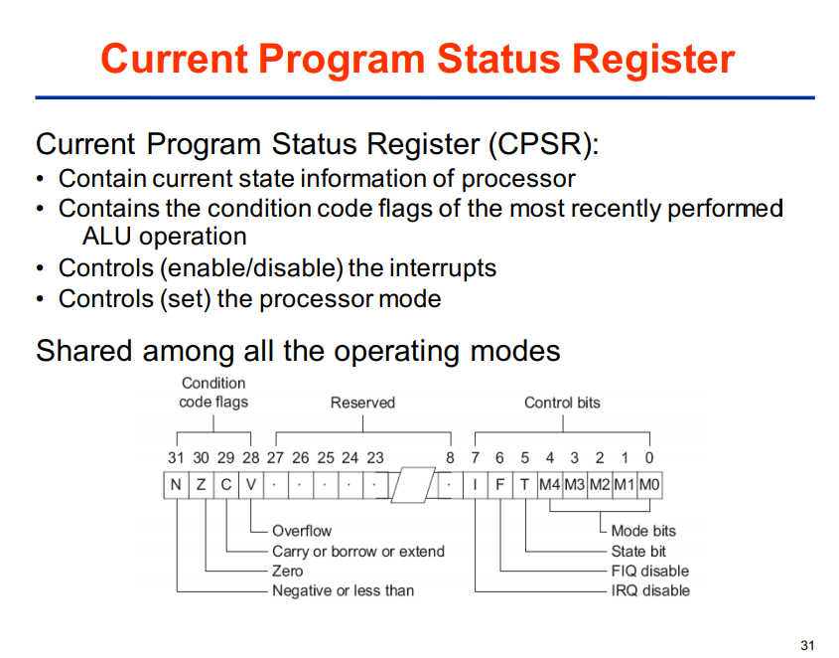

SPSR saved program register saves a copy of the CPSR move it back into CPSR when ready to go back and move LR to PC aswell

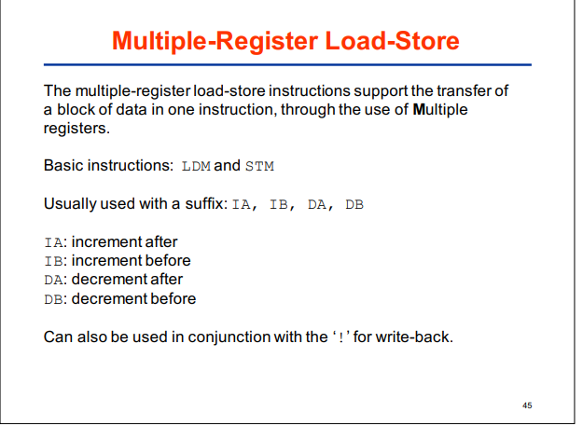

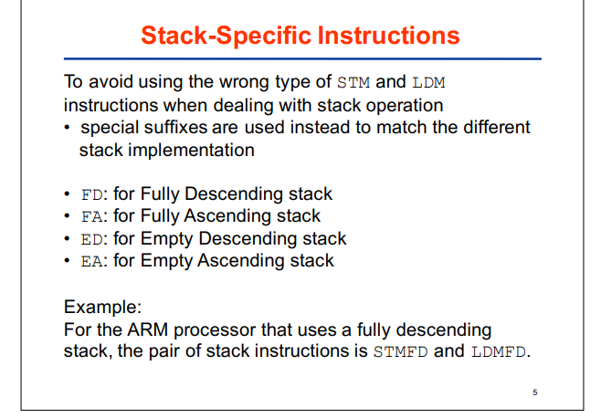

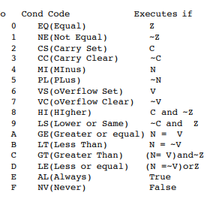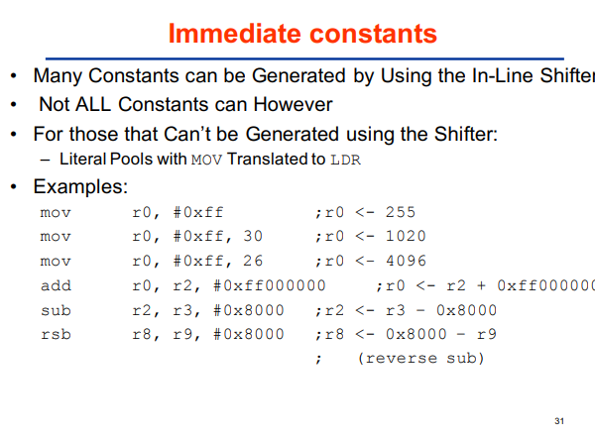

Mvn is move one’s comp